|  |
| --- |
| **EMBEDDED SYSTEM LABORATORY** |
| **LAB 3** |

**MULTITASK PROGRAMMING FOR ARM MICROCONTROLLER WITH ADC INTERFACE**

### I. LAB OBJECTIVES

### - In this Lab students will learn about ARM-CORTEX M3 (LPC1768) Microcontroller.

### - This Lab experiments are intended to implement basic ADC of ARM-CORTEX M3 Microcotroller to pheriperal devices in MB1700 Kit and write C code programming to control these devices.

### II. PRE-LAB : ADC Register Review

### III. LAB PROCERUCE

### The LPC1768 Microconttroler KIT using 100MHz system clock.

### III.1 Lab Experiment 1 : Write the C code to use GLCD Driver Library in GLCD to draw a rectangle 100x100 pixel at position x=50, y=50, then move the rectangle in different position of the LCD screen with moving delay 1 second using timer 1 polling method;

### 

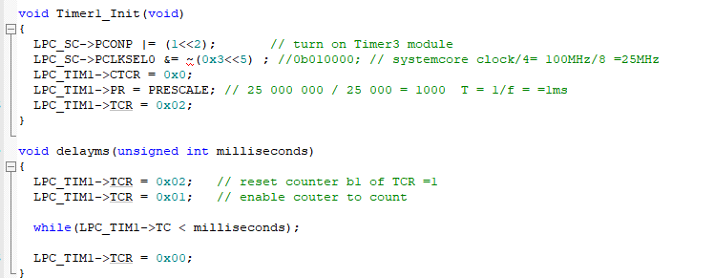

### III.2 Lab Experiment 2 : Write the C code to use GLCD Driver Library in GLCD to draw a bar graph 100x100 pixel at position x=150, y=5; then move the bar graph in different position of the LCD screen with joystick controlled by four buttons P1.23,P1.24,P1.25,P1.26;

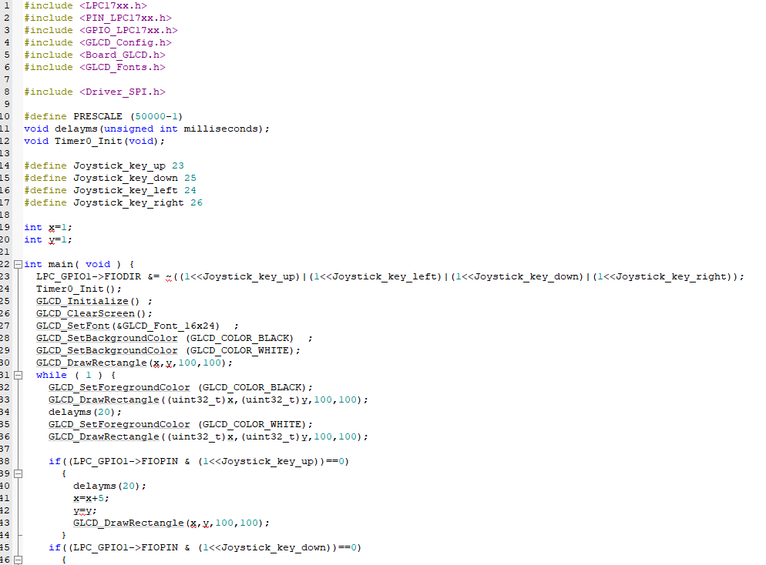

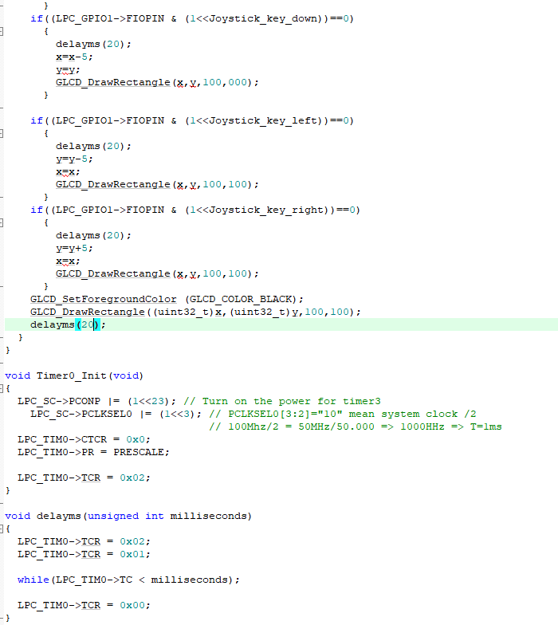

### III.3 Lab Experiment 3 : Write the C code to use GLCD Driver Library in GLCD to display your name at position x=10, y=160 ; then scroll up your name in the screen.

### 

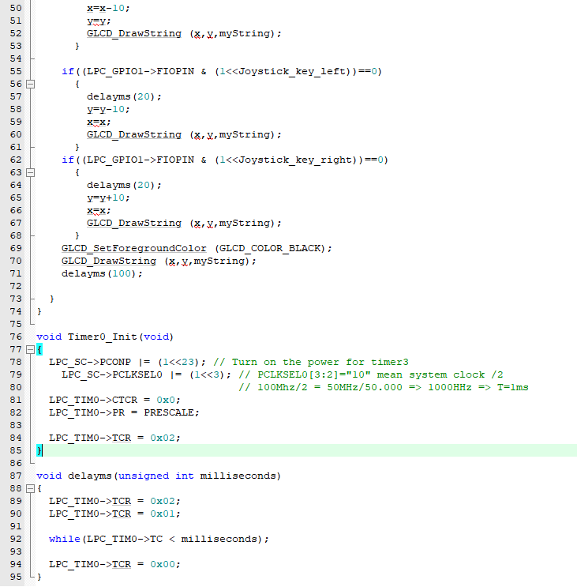

### III.4 Lab Experiment 4 : Write the C code to design the simple snake game. use GLCD Driver Library in GLCD to draw a rectangle 250x250 pixel at position x=1, y=1 ( considered as the wall). draw a rectangle 10x10 pixel at position x=20 y=20, withbgreen colors (considered as a snake); then move the snake to different position of the LCD screen with joystick controlled by four buttons P1.23,P1.24,P1.25,P1.26; When the snake hit the wall, stop the while loop and print out to the GLCD “you are lost”.

### III.5 Lab Experiment 5 : Write the C code to get data From ADC channel 2 using polling method then display 8-bit high value result to 8 bit LED in the Experiment KIT .

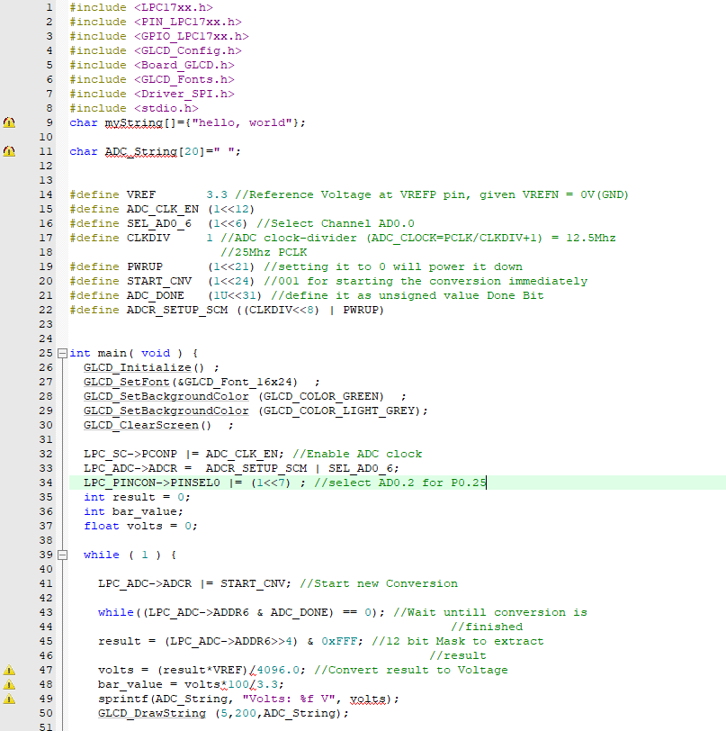

### III.6 Lab Experiment 6 : Write the code to using Timer1 Interrupt to get data From ADC channel 2 using polling method then display 8-bit high value result to 8 bit LED with sampling time 1 second/1 time.

### 

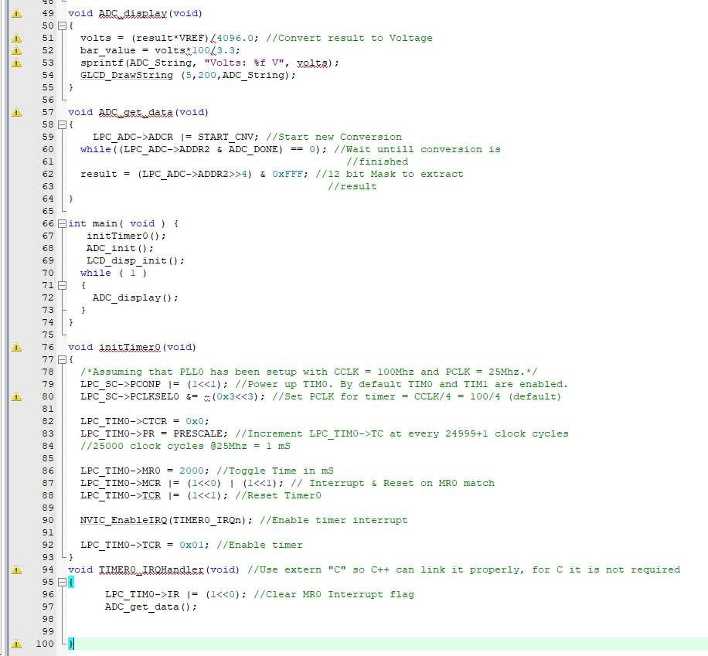

### III.7 Lab Experiment 7 : Write the code to using Timer1 Interrupt to get data From ADC channel 2 using polling method then display 12-bit value result to GLCD in form of text with sampling time 1 second/1 time.

### 

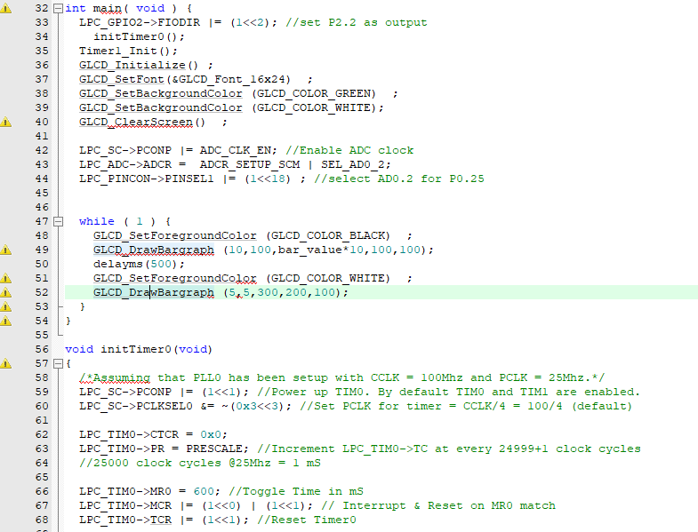

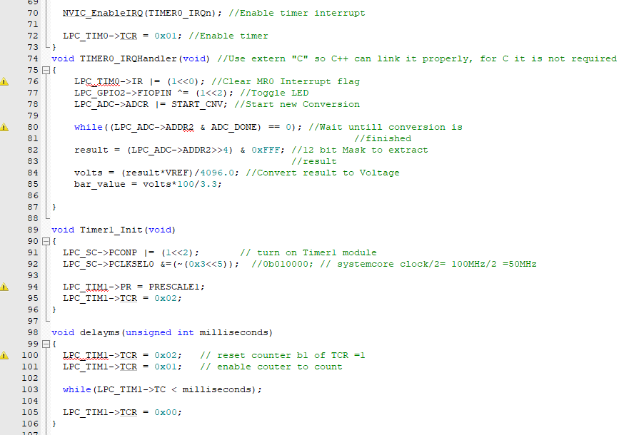

### III.8 Lab Experiment 8 : Write the code to using Timer1 Interrupt to get data From ADC channel 2 using polling method then display 8-bit high value result to 8 bit LED with sampling time 1 second/1 time.

### #include "LPC17xx.h"

### #define POWER_CONTROL (LPC_SC->PCONP)

### #define PINCONSEL1 (LPC_PINCON->PINSEL1)

### #define PINCONSEL2 (LPC_PINCON->PINSEL2)

### #define IO1_DIR (LPC_GPIO1->FIODIR)

### #define IO2_DIR (LPC_GPIO2->FIODIR)

### #define IO1_SET (LPC_GPIO1->FIOSET)

### #define IO2_SET (LPC_GPIO2->FIOSET)

### #define IO1_CLR (LPC_GPIO1->FIOCLR)

### #define IO2_CLR (LPC_GPIO2->FIOCLR)

### #define IO1_PIN (LPC_GPIO1->FIOPIN)

### #define IO2_PIN (LPC_GPIO2->FIOPIN)

### #define LED1_BIT (1 << 6)

### #define LED2_BIT (1 << 5)

### #define LED3_BIT (1 << 4)

### #define LED4_BIT (1 << 3)

### #define LED5_BIT (1 << 2)

### #define LED6_BIT (1 << 31)

### #define LED7_BIT (1 << 29)

### #define LED8_BIT (1 << 28)

### #define VREF 3.3 //Reference Voltage at VREFP pin, given VREFN = 0V(GND)

### #define ADC_CLK_EN (1<<12)

### #define SEL_AD0_2 (1<<2) //Select Channel AD0.0

### #define CLKDIV 1 //ADC clock-divider (ADC_CLOCK=PCLK/CLKDIV+1) = 12.5Mhz

### //25Mhz PCLK

### #define PWRUP (1<<21) //setting it to 0 will power it down

### #define START_CNV (1<<24) //001 for starting the conversion immediately

### #define ADC_DONE (1U<<31) //define it as unsigned value Done Bit

### #define ADCR_SETUP_SCM ((CLKDIV<<8) | PWRUP)

### void leds_init(void)

### {

### POWER_CONTROL |= (1 << 15);

### IO2_DIR = (LED1_BIT | LED2_BIT | LED3_BIT | LED4_BIT | LED5_BIT);

### IO1_DIR = (LED6_BIT | LED7_BIT | LED8_BIT);

### }

### void led_on(unsigned int index)

### {

### switch(index)

### {

### case 1:

### IO2_SET = LED1_BIT;

### break;

### case 2:

### IO2_SET = LED2_BIT;

### break;

### case 3:

### IO2_SET = LED3_BIT;

### break;

### case 4:

### IO2_SET = LED4_BIT;

### break;

### case 5:

### IO2_SET = LED5_BIT;

### break;

### case 6:

### IO1_SET = LED6_BIT;

### break;

### case 7:

### IO1_SET = LED7_BIT;

### break;

### case 8:

### IO1_SET = LED8_BIT;

### break;

### default:

### break;

### }

### }

### void led_off(unsigned int index)

### {

### switch(index)

### {

### case 1:

### IO2_CLR = LED1_BIT;

### break;

### case 2:

### IO2_CLR = LED2_BIT;

### break;

### case 3:

### IO2_CLR = LED3_BIT;

### break;

### case 4:

### IO2_CLR = LED4_BIT;

### break;

### case 5:

### IO2_CLR = LED5_BIT;

### break;

### case 6:

### IO1_CLR = LED6_BIT;

### break;

### case 7:

### IO1_CLR = LED7_BIT;

### break;

### case 8:

### IO1_CLR = LED8_BIT;

### break;

### default:

### break;

### }

### }

### void leds_set_value(char led_Value)

### {

### int i;

### for(i = 0; i < 8; i++)

### {

### if(led_Value & (1<<i))

### {

### led_on(i+1);

### }

### else

### {

### led_off(i+1);

### }

### }

### }

### void ADC_Initialize(void)

### {

### LPC_SC->PCONP |= ADC_CLK_EN; //Enable ADC clock

### LPC_ADC->ADCR = ADCR_SETUP_SCM | SEL_AD0_2;

### LPC_PINCON->PINSEL1 |= (1<<18) ; //select AD0.2 for P0.25

### 

### }

### void ADC_StartConversion(void)

### {

### LPC_ADC->ADCR |= START_CNV; //Start new Conversion

### }

### int main()

### {

### leds_init();

### ADC_Initialize();

### int ADC_Value;

### char led_value;

### while(1)

### {

### ADC_StartConversion();

### while((LPC_ADC->ADDR2 & ADC_DONE) == 0); //Wait untill conversion is

### //finished

### ADC_Value = (LPC_ADC->ADDR2>>8) & 0xFF; //12 bit Mask to extract

### //result

### led_value = (char) ADC_Value;

### leds_set_value(led_value);

### }

### }

**IV. LAB PERFORMANCE GRADING AND LAB REPORT GUIDELINES**

For each Lab experiment Students show the successful running results to Lab Instructor for Lab Performance grading.

Students write a report which includes : Algorithm flowchart and C++ Code for each experiment. In each block of the code or line of code, give the comments for the meaning of this block of code.